DYNAMIC BEHAVIOUR
A. Rusinek¹, T. Jankowiak²
¹National Engineering School of Metz, Laboratory of Mechanics, Biomechanics, Polymers and Structures, 1 route d’Ars Laquenexy, 57000 Metz,, France
²Poznan University of Technology, Institute of Structural Engineering,
Piotrowo 5, 60-965 Poznan, Poland
Abstract
Text of the abstract. The total length of the abstract is 2 pages. The text can include figures, tables and equations formatted using the following methods.
Equation.
$$σ\left(ε_{P},{\dot{ε}}_{P},T\right)=\left(A+B{{\dot{ε}}_{P}}^{n}\right)\left(1+C\ln{\frac{{\dot{ε}}_{P}}{{\dot{ε}}_{0}}}\right)\left(1-{\left(\frac{T-T_{0}}{T_{m}-T_{0}}\right)}^{m}\right)$$ | (1)
Figures or curves should be included in high quality.

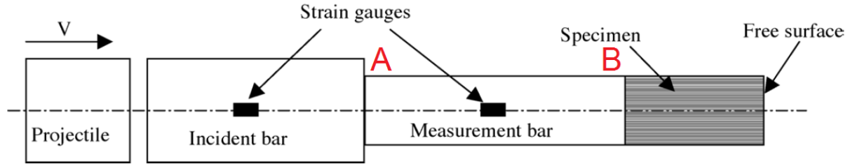
Fig. 1. Spalling instrumentation
Table.
Tab. 1. The values from analytical calculations
 | $$t_{loading}(s)$$ | $$σ_{I} (MPa)$$ | $$σ_{T1}(MPa)$$ | $$σ_{R1}(MPa)$$ | $$C_{p} (m/s)$$ | $$C_{b} (m/s)$$
7 m/s | 0,0001293 | 50,222 | 86,590 | -36,367 | 4948,006 | 4948,006
15 m/s |  | 107,619 | 185,550 | -77,931
References:
[1] T. Jankowiak, T. Łodygowski Smoothed particle hydrodynamics versus finite element method for blast impact , Bulletin of the Polish Academy of Sciences, 61, 1, 111-121, 2013
[2] T. Jankowiak, A. Rusinek, P. Wood, Comments on paper: “Glass damage by impact spallation” by A. Nyoungue et al., Materials Science and Engineering A 407 (2005) 256–264, Materials Science and Engineering A, 564, 206–212, 2013

Authors:
Alexis Rusinek
e-mail address: rusinek@enim.fr, tel.: +33-3-87 31 50 20
Tomasz Jankowiak
e-mail address: tomasz.jankowiak@put.poznan.pl, tel.: +48-61 665 2814

